Facts: Real-Estate-Property price sold at.

Measures

* Average Final Property Price
  + Store price sold when data is “removed’ from operational DB signalling it’s sale.
  + Select avg(final_price) from warehouse
* Average Asking Property Price
  + Select the avg(asking_price) from warehouse
* Average time property was sold
  + Store sale date in warehouse.
  + Select the avg(list_date – sale_date) from warehouse
* Number of buyers
  + Store table of each interaction of buyer with the property
  + Select count(*) of buyer ID per property.

Dimensions

* Date of “date-when-on-market”
* Date when listing is removed ( as it was sold)
* Real-Estate-Property
* Buyer
* Agent
* Owner

Hierarchies

* Time
  1. All
  2. Year
  3. Month
  4. Day
* Real-Estate-Property
  1. All
  2. Country
  3. City
  4. Street
  5. Real-Estate-Property
* Owner
  1. All
  2. Country
  3. City
* Buyer
  1. All
  2. Country
  3. City
* Agent
  1. All
  2. Country
  3. City

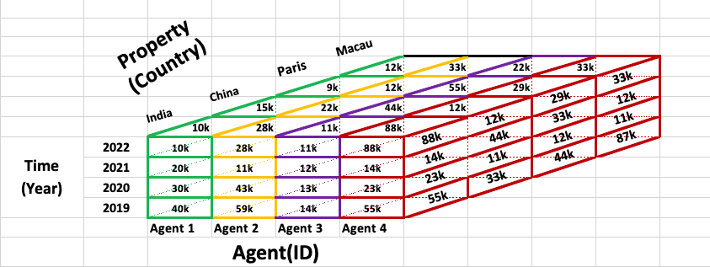

Data Cube to find (3) average final price sold.

Measure: Average Final price sold